**Scoring Metrics**

**Scored pathologies**

In our DataBases, there are roughly 120 pathologies. However, not all of them are scored: 27 scored pathologies. Among these 27 pathologies, There are groups of pathologies that are considered exactly the same:

* PVC and VPB
* PAC and SVPB
* CRBBB and RBBB

Therefore, there are **24 different scored pathologies.**

**Choice of Training**

We chose not to insert the ‘other’ pathologies in our training phase. Indeed, the output of our classifier on ‘other’ pathologies does not count. Therefore, we do not want our classifier to learn the existence of other pathologies in case it would classify a scored pathology as an unscored one.

**How to compute ?**

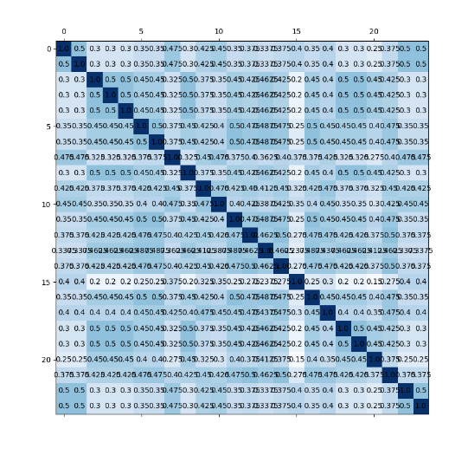

This is the weight matrix, which is weighting the misclassification between pathologies: some misclassifications are **more serious** than others: different from the unofficial fbeta score.

Basically, you compute the confusion matrix of your model and then you sum the scalar products columnwise.